A
Real-Time Research Project Report
On
CLASSIFICATION OF FRACTURED BONES USING MACHINE LEARNING
(Submitted in partial fulfillment of the requirements for the award of Degree)
BACHELOR OF TECHNOLOGY
In
COMPUTER SCIENCE AND ENGINEERING (DATA SCIENCE)
By
P.MANIDEEP CHARY : 247R1A67Q1
M.SANJAY : 247R1A67P4
RIYAN SHEIK : 247R1A67Q6
U.NEHA :247R1A67R3
Under the Guidance of
Mr. B RAMESH
(Assistant Professor)

DEPARTMENT OF COMPUTER SCIENCE AND ENGINEERING (DATA SCIENCE)
CMR TECHNICAL CAMPUS
UGC AUTONOMOUS
(Accredited by NAAC, NBA, Permanently Affiliated to JNTUH, Approved by AICTE, New Delhi)
Recognized Under Section 2(f) & 12(B) of the UGC Act.1956, Kandlakoya (V), Medchal Road, Hyderabad-501401.
April, 2026.
DEPARTMENT OF COMPUTER SCIENCE AND ENGINEERING (DATA SCIENCE)


CERTIFICATE

This is to certify that the project entitled "CLASSIFICATION OF FRACTURED BONES USING MACHINE LEARNING" being submitted by P.MANIDEEP CHARY : 247R1A67Q1 , M.SANJAY : 247R1A67P4 , RIYANSHEIK: 247R1A67Q6 , U.NEHA (247R1A67R3)
in partial fulfillment of the requirements for the award of the degree of B.Tech in Computer Science and Engineering to the Jawaharlal Nehru Technological University Hyderabad, during the year 2025-2026.
The results embodied in this thesis have not been submitted to any other University or Institute for the award of any degree or diploma.

Mr . B RAMESH Dr. K. Murali
Assistant Professor HOD-CSE(DS)
INTERNAL GUIDE

ACKNOWLEDGEMENT

We take this opportunity to express our gratitude to the people who have been instrumental in the successful completion of this project. We take this opportunity to express our profound gratitude and deep regard to our guide Mr. B RAMESH (Assistant Professor) for his exemplary guidance, monitoring and constant encouragement throughout the project work. The blessing, help and guidance given by him shall carry us a long way in the journey of life on which we are about to embark.
We also take this opportunity to express a deep sense of gratitude to the Project Review Committee (PRC) coordinators K. Sudha Pavani, Laxman B, Dr. B. Mohan Babu, K. Jhansi Rani, V. Prema Tulasi, A. Lakshman, Sanjib Kumar Nayak, E. Sushma, Dr. A. Mahendar for their cordial support, valuable information and guidance, which helped us in completing this task through various stages.

We are also thankful to Dr. K. Murali, Head, Department of Computer Science and Engineering (Data Science) for providing encouragement and support for completing this project successfully.
We are deeply grateful to Dr. A. Raji Reddy, Director, for his cooperation throughout the course of this project. Additionally, we extend our profound gratitude to Sri. Ch. Gopal Reddy, Chairman, Smt. C. Vasantha Latha, Secretary and Sri. C. Abhinav Reddy, Vice-Chairman, for fostering an excellent infrastructure and a conducive learning environment that greatly contributed to our progress.
The guidance and support received from all the members of CMR Technical Campus who contributed to the completion of the project. We are grateful for their constant support and help.
Finally, we would like to take this opportunity to thank our family for their constant encouragement, without which this assignment would not be completed. We sincerely acknowledge and thank all those who gave support directly and indirectly in the completion of this project.

By
P.MANIDEEP CHARY : 247R1A67Q1
M.SANJAY : 247R1A67P4
RIYAN SHEIK : 247R1A67Q6
U.NEHA :247R1A67R3

ABSTRACT

Technologies that are rapidly growing are appearing every day in a variety of disciplines, particularly the medical one. However, there are still certain outdated methods that are still widely used, effective, and efficient. One of these methods is the use of X-rays to identify damaged bones . However, sometimes the number of fractures is insignificant and difficult to see. Systems should be created that are efficient and intelligent. In this study, an artificial classification system that can recognize and categorize bone fractures is being developed. There are one main steps in the system that has been designed. The photos of the fractures are processed in the first stage using various image processing techniques to identify their shapes. The classification phase follows, in which a back propagation neural network training on the processed images before being put to the test. The system was put to the test experimentally on various photographs of bone fractures, and the results indicate high performance as well as a classification rate..

CLASSIFICATION OF FRACTURED BONES USING MACHINE LEARNING
1. INTRODUCTION:
In human body, there are total 206 types of different bones. Each bone has its own importance. It is very important to correctly identify human bone and then suggest treatment. To classify the human bones, we will use Musculoskeletal Radiographs (MURA) dataset. MURA dataset is one of the largest public radiographic image datasets. MURA dataset contains total 40,005 x-ray images of 14,052 patients, in which 36,808 images use as a training set and rest 3197 images use the testing set. These all images belong to seven different categories of bones such as finger, elbow, hand, forearm, humerus, wrist and shoulder.A machine can be learned in two different ways either as supervised learning or unsupervised learning. In supervised learning, already we have some labeled data through which we train our machine and perform classification/prediction based on training . In unsupervised learning, we have unlabeled data. In our case, we used supervised learning to train our machine. Classification is a concept of supervised machine learning in which the computer learns from the labeled data we input and then uses this learning to classify new data given to it. Classification is used to predict the category of data we provide. For the classification of human bones, we require some x-ray images of the different body part. For that region, we used Musculoskeletal Radiographs (MURA) dataset. This MURA dataset contains seven different categories of human bones belonging to Elbow, Hand, Wrist, Shoulder, Finger, Humorous and Forearm. Each category of bone has some x-ray images with respect to the number of patients
1.1 Objective of the project:
Technologies that are rapidly growing are appearing every day in a variety of disciplines, particularly the medical one. However, there are still certain outdated methods that are still widely used, effective, and efficient. One of these methods is the use of X-rays to identify damaged bones . However, sometimes the number of fractures is insignificant and difficult to see. Systems should be created that are efficient and intelligent. In this study, an artificial classification system that can recognize and categorize bone fractures is being developed. There are one main steps in the system that has been designed. The photos of the fractures are processed in the first stage using various image processing techniques to identify their shapes. The classification phase follows, in which a back propagation neural network training on the processed images before being put to the test. The system was put to the test experimentally on various photographs of bone fractures, and the results indicate high performance as well as a classification rate..
2. LITERATURE SURVEY:
“A Robust Approach For Detection of the type of Fracture from XRay Images”
A bone is broken or a fracture in bone happens when an external force applied upon the bone is more than what the bone can tolerate or bear. As a result, the shape and strength of the bone is disturbed which causes excruciating pain on the bone and ends up in the loss of functioning of the bone? In some instances there will be bleeding around the injured site. The modern developments in medical imaging contribute a lot in examining the fractures in different kinds and classes of bones found in the body of the patient without much difficulty. Segmentation of an image involves a process called edge detection. The purpose of segmentation is to modify the representation of an image into fragments that is bits and pieces that are more important, useful and easier to analyze. To identify the edges, this function scans for regions in the image where the change of intensity occurs rapidly. Edge detection returns a binary image containing ones where edges are found and zeros in all other places. Different edge detection methods exist like Sober operator, Prewitt operator, Palladian of a Gaussian and Canny. These techniques can be applied on X-ray medical images. Quality metrics like mean and standard deviation are applied to analyze, compare and evaluate the results. The process of detecting the type of fracture has to be done with a great precision. To improve these quality metrics, a novel edge detection algorithm is proposed and the accuracy is measured for this cause.
“Bone Fracture Detection Using Image Processing in Mat lab”
The image processing technique is extremely helpful for several applications like biomedical, security, satellite imaging, personal image, medicine, etc. The implementation of image processing such as image enhancement and feature segmentation and feature excitation are used for fracture detection. This paper uses canny edge detection methodology for segmentation. The canny method produces perfect information from the bone image. The main aim of this research is to detect Bone fractures using image processing using MATLAB. The proposed system has the following steps, namely, preprocessing, segmentation, and fracture detection.in feature excitation step, the paper uses to Hough Transform technique for line detection inline-image. Feature extraction is the main task of the system. the results from various experiments show that the proposed system is very accurate and efficient Introduction: Bone fracture is a common problem in every developed countries and the number of fractures also increasing day by day very rapidly. A bone fracture may occur due to simple accidents or different types of diseases. So, for that quick and accurate diagnosis crucial to the success of any prescribed treatment. Depending upon the human experts alone for such a critical matter have cause intolerance errors. Hence the thought of automatic identification procedure has perpetually been associate degree appealing one. The main goal of the paper is to detect the bone fracture from X-ray images using MATLAB software. The lower long bone is that the second largest bone of the body. It is made up of two bones, the tibia, and the fibula. The fibula bone is smaller and thinner than the tibia. However, the tibia fracture is most commonly occurring due to it carries a significant portion of the body weight. The normal bone demonstration is given in Fig(1). Among the four modalities (X-ray, CT, MRI, Ultrasound), X-ray diagnosis is commonly used for bone fracture detection due to their low cost, high speed, and wide availability. Although CT and magnetic resonance imaging pictures provide higher quality pictures for body organs than X-ray pictures, the latter is faster cheaper, enjoy wider availability and are easier to use few limitations. Moreover, the level of quality of X-ray images is enough for bone fracture detection. The motivations of this system are: 1. Saving time for patients to lower the workload of doctors by screening out the easy case. 2. To cut back human errors as a result of doctors in hospitals manually examine an outsized variety of X-ray pictures for fracture.
“Classification of long-bone fractures based on digital geometric analysis of X-ray images,”
The classification of fractured of a patient plays an important role in orthopaedic evaluation and diagnosis. It not only aids in assessing the severity of the disease or injury but also serves as a basis of treatment or surgical correction. This paper proposes a novel approach to automated classification of long-bone fractures based on the analysis of an input X-ray image. The method consists of four major steps: (i) extraction of the bone-contour from a given X-ray image, (ii) identification of fracture-points or cracks, (iii) determination of an equivalent set of geometric features in tune with the Muller-AO clinical classification of fractures, and (iv) identification and detailed assessment of the fracture-type. The decision procedure makes use of certain geometric properties of digital curves such as relaxed digital straight line segments (RDSS), arcs, discrete curvature, and concavity index. The proposed method for the analysis of fractures is applied on different types of bone-images and is observed to have produced correct classification in most of the test-cases.
“Design , Development and Analysis of Femur Bone by using Rapid Prototyping,”
Most of the bone fractures in daily life occur within the arm bone and femur bones. Machining of medical science alloy implants, with high speed machining, offers blessings, however additionally has its own disadvantages metallic element, steel etc. are used as bone replacement; however the implants are unit straightforward geometric approximations of the bone. There is lot of probabilities of mismatches to occur between real bone and implants, which regularly causes stress concentrations and premature implant failure. To beat this stress concentration and unsustainable pain correct bone implant is needed. By Appling Rapid prototyping we are able to prepare the image to induce physical model of bone. This can be helpful to manufacture correct bone implant. This paper tries to utilize the advanced Computer Aided Design and Finite component Analysis to notice and perceive the stress within the femur bone, and aid within the manufacture of artificial joints and limbs. This method takes input from CT scan or MRI, That is then fed into CAD by using different software’s like MIMIC and 3D slicer. This CAD file can be used in prototyping the bone by using different methods of Rapid Prototyping. And it will help in different medical application.
“Automatic Detection of Radius of Bone Fracture,”
Automatic detection of radius of bone fracture in a x-ray image is considered as major process in image analysis by doctors and as well as radiologist now days, with increasing fracture rate due to vehicle accidents, age related issues and over physical activity by human beings. This paper proposed an algorithm for automatic detection of radius of bone fracture in all bones of the human body. The proposed system involves major steps, which includes image preprocessing, segmentation, feature extraction and radius of bone fracture detection. By the use of Hough transform radius of bone fracture is obtained. HT method shows the clear efficient and accurate results. MATLAB 2013 programming tool is used for the execution of the project.
“A Study of Various Bone Fracture Detection Techniques,”
The bone fracture is common problem in human beings due to accident or other causes like bone cancer etc. The fracture can occur in any bone of our body like wrist, heel, ankle, hip, rib, leg, chest etc. It is not possible to view fractures by naked eyes, so X-ray/CT images are used to detect it. But sometimes these images lack sufficient details needed to diagnose. Now a days image processing is playing an important role in bone fracture detection. Image processing is important in modern data storage and data transmission especially in progressive transmission of images, video coding (teleconferencing), digital libraries, image database, and remote sensing. This paper presents a study of image processing techniques for bone fracture detection. This paper will help user to study different methods for bone fracture detection using image processing and to design new techniques to improve accuracy of fracture detection. This paper also presents technologies used to implement image processing based system for fracture detection with pros and cons.
“Detection of Fractures in Orthopedic X-Ray Images,”
Computer detection of fractures in orthopedic X-ray images is very difficult and stimulating process. Bones can crack in multiple ways having a variety of degrees of severity. The Severe fractures effect drastically to the shape of the longest bones, mild fractures do not affect gammon’s shape and only elusive indications are observed in orthopedic X-ray images. A Large number of image processing procedures have been tested with orthopedic X-ray images having several types of fractures. The proposed work is to designate the fractures in orthopedic X-Ray images using edge detection, intensity based segmentation and frequency transformation based methods. An analysis has been performed using proposed algorithm on various orthopedic X-ray images depending upon the image characteristics and fracture type. The proposed work discovered an image processing algorithm that first performs orthopedic X-ray image enhancement, then performs the segmentation of region of interest of bone along with edge detection and feature extraction of broken area of bones. Then by applying morphological filtering, determines the expected region of fracture in test orthopedic X-Ray image. The analysis reveals improvement in timeliness and accuracy in clinical diagnosis. Results outshined both quantitatively as well as qualitatively when compared with other existing techniques. Also the clinical validation of Results has been performed.
3. SYSTEM ANALYSIS
3.1 Existing System
It is possible to determine the age of a fracture as acute (less than 1 week), recent (2–5 weeks) and old (6 weeks or more) based on the presence or absence of six variables in combination. The application of this dating tool now needs to be validated in practise. Therefore, the absolute majority of fractures and dislocations were treated non-operatively. Development of operative treatment of fractures was influenced by three major inventions: anaesthesia (1846), antisepsis (1865) and X-rays (1895).
Disadvantages of Existing System:
- Less Accuracy
3.2 Proposed System
In this paper author is using Machine Learning Algorithm called Random Forest to predict/classify bone type and to train Random Forest algorithm author has used various types of bones images but author has not publish used dataset so I am using MURA bones dataset to train Random Forest Algorithm and then when we upload test image then Random Forest will classify type of uploaded bone image this classification will help in identifying fractures in bones whether fracture is in finger or hand or wrist Advantages of Proposed System:
- High Accuracy.
Modules Information:
To implement this project author has designed following modules
- Dataset Collection/Upload: using this module we will upload bones dataset to application
- Features Extraction: using this module we will extract RGB pixel values from each images and then build a future vector
- Train and Test data split: using this module we will split dataset into train and test part where application will use 80% dataset size for training and 20% for testing
- Build Random Forest Model: using this module we will train Random Forest Algorithm on above splitted train dataset and then apply this random forest algorithm on test data to calculate how much correctly random forest predict test images
- Upload Test Image & Classify Bone: using this module we will upload test image and then random forest will classify type of bones.
FUNCTIONAL REQUIREMENTS:
SOFTWARE REQIREMENTS:
System Atributes:
- filename
- X, Y
- X_train, X_test, y_train, y_test

Data base Requirements:
No need
USECASE:
- Use cases - Use cases describe the interaction between the system and external users that leads to achieving particular goals.
- Each use case includes main elements:
- Dataset Collection/Upload
- Features Extraction
- Train and Test data split
- Build Random Forest Model
- Upload Test Image & Classify Bone
User Stories: we can see dataset contains 216 images and then application using 172 images for training and 44 images for testing. Now train and test data is ready and now click on ‘Build Random Forest Model’ button to train Random Forest
Work down Structure:

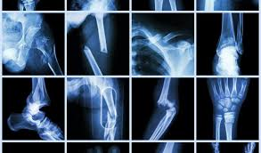
Fig.3.1:Work down Structure
Prototype:
python 3.7.0 or 3.7.4
opencv-python==4.5.1.48
keras==2.3.1
tensorflow==1.14.0
protobuf==3.16.0
h5py==2.10.0
sklearn-extensions==0.0.2
scikit-learn==0.22.2.post1
Numpy
Pandas
Models and Diagrams:
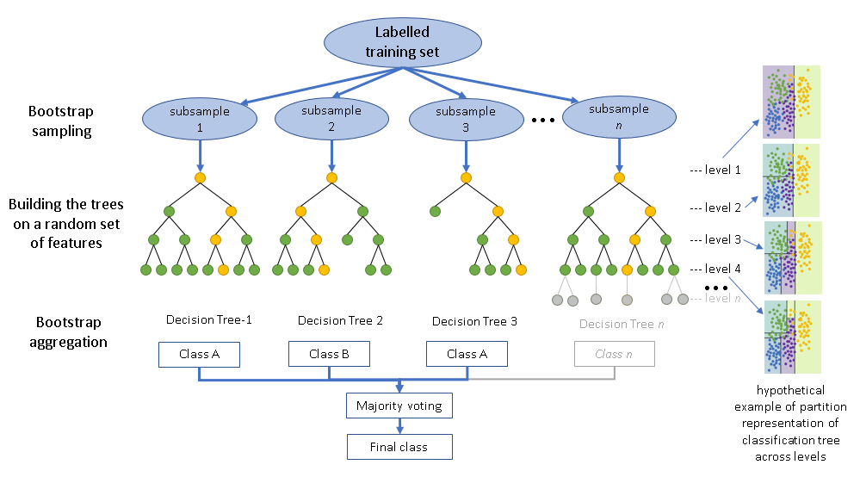

Fig.3.2:Models and Diagram
NON-FUNCTIONAL REQUIREMENT:
Usability: Usability is a quality attribute that assesses how easy user interfaces are to use. The word "usability" also refers to methods for improving ease-of-use during the design process.(how it was handle entire project easy)
Security: the quality or state of being secure: such as. a : freedom from danger : safety. b : freedom from fear or anxiety. c : freedom from the prospect of being laid off job security.
Readability: Readability is the ease with which a reader can understand a written text.
Performance: the execution of an action. : something accomplished : deed, feat. : the fulfillment of a claim, promise, or request : implementation. 3. : the action of representing a character in a play.
Availability: the quality or state of being available trying to improve the availability of affordable housing. 2 : an available person or thing.
Scalability: Scalability is the measure of a system's ability to increase or decrease in performance and cost in response to changes in application and system processing demands.
3.3. PROCESS MODEL USED WITH JUSTIFICATION
SDLC (Umbrella Model):
Umbrella Activity
Umbrella Activity
Umbrella Activity
- Feasibility Study
- TEAM FORMATION
- Project Specification PREPARATION

Business Requirement Documentation
ANALYSIS & DESIGN
CODE
UNIT TEST
DOCUMENT CONTROL

ASSESSMENT

TRAINING
INTEGRATION & SYSTEM TESTING

DELIVERY/INSTALLATION
ACCEPTANCE TEST
Requirements Gathering
Fig.3.3: SDLC (Umbrella Model)
SDLC is nothing but Software Development Life Cycle. It is a standard which is used by software industry to develop good software.
Stages in SDLC:
- Requirement Gathering
- Analysis
- Designing
- Coding
- Testing
- Maintenance

Requirements Gathering stage:
The requirements gathering process takes as its input the goals identified in the high-level requirements section of the project plan. Each goal will be refined into a set of one or more requirements. These requirements define the major functions of the intended application, define operational data areas and reference data areas, and define the initial data entities. Major functions include critical processes to be managed, as well as mission critical inputs, outputs and reports. A user class hierarchy is developed and associated with these major functions, data areas, and data entities. Each of these definitions is termed a Requirement. Requirements are identified by unique requirement identifiers and, at minimum, contain a requirement title and textual description.
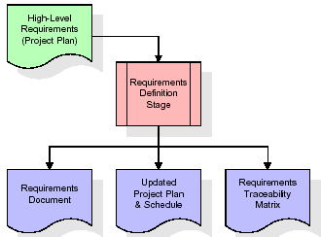

Fig.3.4: Gathering Stage
These requirements are fully described in the primary deliverables for this stage: the Requirements Document and the Requirements Traceability Matrix (RTM). The requirements document contains complete descriptions of each requirement, including diagrams and references to external documents as necessary. Note that detailed listings of database tables and fields are not included in the requirements document.
The title of each requirement is also placed into the first version of the RTM, along with the title of each goal from the project plan. The purpose of the RTM is to show that the product components developed during each stage of the software development lifecycle are formally connected to the components developed in prior stages.
In the requirements stage, the RTM consists of a list of high-level requirements, or goals, by title, with a listing of associated requirements for each goal, listed by requirement title. In this hierarchical listing, the RTM shows that each requirement developed during this stage is formally linked to a specific product goal. In this format, each requirement can be traced to a specific product goal, hence the term requirements traceability.
The outputs of the requirements definition stage include the requirements document, the RTM, and an updated project plan.
- Feasibility study is all about identification of problems in a project.
- No. of staff required to handle a project is represented as Team Formation, in this case only modules are individual tasks will be assigned to employees who are working for that project.
- Project Specifications are all about representing of various possible inputs submitting to the server and corresponding outputs along with reports maintained by administrator.
Analysis Stage:
The planning stage establishes a bird's eye view of the intended software product, and uses this to establish the basic project structure, evaluate feasibility and risks associated with the project, and describe appropriate management and technical approaches.
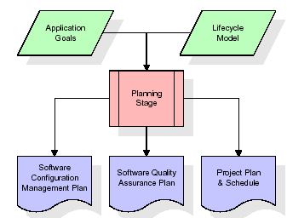
Fig.3.5: Analysis Stage
The most critical section of the project plan is a listing of high-level product requirements, also referred to as goals. All of the software product requirements to be developed during the requirements definition stage flow from one or more of these goals. The minimum information for each goal consists of a title and textual description, although additional information and references to external documents may be included. The outputs of the project planning stage are the configuration management plan, the quality assurance plan, and the project plan and schedule, with a detailed listing of scheduled activities for the upcoming Requirements stage, and high level estimates of effort for the out stages.

Designing Stage:
The design stage takes as its initial input the requirements identified in the approved requirements document. For each requirement, a set of one or more design elements will be produced as a result of interviews, workshops, and/or prototype efforts. Design elements describe the desired software features in detail, and generally include functional hierarchy diagrams, screen layout diagrams, tables of business rules, business process diagrams, pseudo code, and a complete entity-relationship diagram with a full data dictionary. These design elements are intended to describe the software in sufficient detail that skilled programmers may develop the software with minimal additional input.
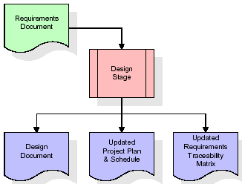
Fig.3.6:Designing Stage
When the design document is finalized and accepted, the RTM is updated to show that each design element is formally associated with a specific requirement. The outputs of the design stage are the design document, an updated RTM, and an updated project plan.
Development (Coding) Stage:
The development stage takes as its primary input the design elements described in the approved design document. For each design element, a set of one or more software artifacts will be produced. Software artifacts include but are not limited to menus, dialogs, and data management forms, data reporting formats, and specialized procedures and functions. Appropriate test cases will be developed for each set of functionally related software artifacts, and an online help system will be developed to guide users in their interactions with the software.
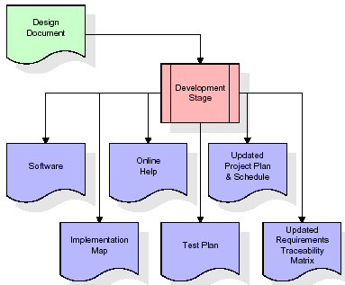
Fig.3.7:Development Stage
The RTM will be updated to show that each developed artifact is linked to a specific design element, and that each developed artifact has one or more corresponding test case items. At this point, the RTM is in its final configuration. The outputs of the development stage include a fully functional set of software that satisfies the requirements and design elements previously documented, an online help system that describes the operation of the software, an implementation map that identifies the primary code entry points for all major system functions, a test plan that describes the test cases to be used to validate the correctness and completeness of the software, an updated RTM, and an updated project plan.
Integration & Test Stage:
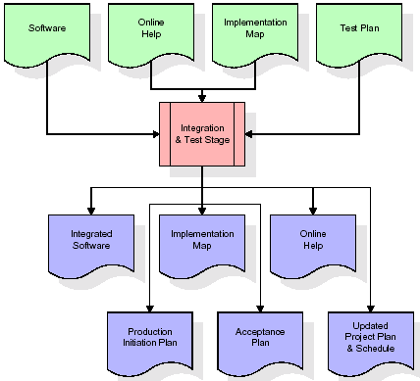
During the integration and test stage, the software artifacts, online help, and test data are migrated from the development environment to a separate test environment. At this point, all test cases are run to verify the correctness and completeness of the software. Successful execution of the test suite confirms a robust and complete migration capability. During this stage, reference data is finalized for production use and production users are identified and linked to their appropriate roles. The final reference data (or links to reference data source files) and production user list are compiled into the Production Initiation Plan.

Fig.3.8:TestStage
The outputs of the integration and test stage include an integrated set of software, an online help system, an implementation map, a production initiation plan that describes reference data and production users, an acceptance plan which contains the final suite of test cases, and an updated project plan.

- Installation & Acceptance Test:
During the installation and acceptance stage, the software artifacts, online help, and initial production data are loa ded onto the production server. At this point, all test cases are run to verify the correctness and completeness of the software. Successful execution of the test suite is a prerequisite to acceptance of the software by the customer.
After customer personnel have verified that the initial production data load is correct and the test suite has been executed with satisfactory results, the customer formally accepts the delivery of the software.
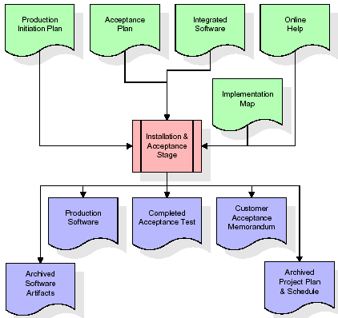

Fig.3.9:Installation & Acceptance Stage
The primary outputs of the installation and acceptance stage include a production application, a completed acceptance test suite, and a memorandum of customer acceptance of the software. Finally, the PDR enters the last of the actual labor data into the project schedule and locks the project as a permanent project record. At this point the PDR "locks" the project by archiving all software items, the implementation map, the source code, and the documentation for future reference.

Maintenance:
Outer rectangle represents maintenance of a project, Maintenance team will start with requirement study, understanding of documentation later employees will be assigned work and they will undergo training on that particular assigned category. For this life cycle there is no end, it will be continued so on like an umbrella (no ending point to umbrella sticks).
3.4. Software Requirement Specification
3.4.1. Overall Description
A Software Requirements Specification (SRS) – a requirements specification for a software system is a complete description of the behavior of a system to be developed. It includes a set of use cases that describe all the interactions the users will have with the software. In addition to use cases, the SRS also contains non-functional requirements. Nonfunctional requirements are requirements which impose constraints on the design or implementation (such as performance engineering requirements, quality standards, or design constraints).
System requirements specification: A structured collection of information that embodies the requirements of a system. A business analyst, sometimes titled system analyst, is responsible for analyzing the business needs of their clients and stakeholders to help identify business problems and propose solutions. Within the systems development lifecycle domain, the BA typically performs a liaison function between the business side of an enterprise and the information technology department or external service providers. Projects are subject to three sorts of requirements:
- Business requirements describe in business terms what must be delivered or accomplished to provide value.
- Product requirements describe properties of a system or product (which could be one of several ways to accomplish a set of business requirements.)
- Process requirements describe activities performed by the developing organization. For instance, process requirements could specify .Preliminary investigation examine project feasibility, the likelihood the system will be useful to the organization. The main objective of the feasibility study is to test the Technical, Operational and Economical feasibility for adding new modules and debugging old running system. All system is feasible if they are unlimited resources and infinite time. There are aspects in the feasibility study portion of the preliminary investigation:
- ECONOMIC FEASIBILITY
A system can be developed technically and that will be used if installed must still be a good investment for the organization. In the economical feasibility, the development cost in creating the system is evaluated against the ultimate benefit derived from the new systems. Financial benefits must equal or exceed the costs. The system is economically feasible. It does not require any addition hardware or software. Since the interface for this system is developed using the existing resources and technologies available at NIC, There is nominal expenditure and economical feasibility for certain.
- Operational Feasibility
Proposed projects are beneficial only if they can be turned out into information system. That will meet the organization’s operating requirements. Operational feasibility aspects of the project are to be taken as an important part of the project implementation. This system is targeted to be in accordance with the above-mentioned issues. Beforehand, the management issues and user requirements have been taken into consideration. So there is no question of resistance from the users that can undermine the possible application benefits. The well-planned design would ensure the optimal utilization of the computer resources and would help in the improvement of performance status.
- TECHNICAL FEASIBILITY
Earlier no system existed to cater to the needs of ‘Secure Infrastructure Implementation System’. The current system developed is technically feasible. It is a web based user interface for audit workflow at NIC-CSD. Thus it provides an easy access to .the users. The database’s purpose is to create, establish and maintain a workflow among various entities in order to facilitate all concerned users in their various capacities or roles. Permission to the users would be granted based on the roles specified. Therefore, it provides the technical guarantee of accuracy, reliability and security.
3.4.2. External Interface Requirements
User Interface
The user interface of this system is a user friendly python Graphical User Interface.
Hardware Interfaces
The interaction between the user and the console is achieved through python capabilities.
Software Interfaces
The required software is python.
SYSTEM REQUIREMENT:
HARDWARE REQUIREMENTS:

Processor - Intel i3(min)
- Speed - 1.1 GHz
- RAM - 4GB(min)
- Hard Disk - 500 GB
- Key Board - Standard Windows Keyboard
- Mouse - Two or Three Button Mouse
- Monitor - SVGA
SOFTWARE REQUIREMENTS:
- Operating System - Windows10(min)
- Programming Language - Python

4. SYSTEM DESIGN
CLASS DIAGRAM:
The class diagram is the main building block of object oriented modeling. It is used both for general conceptual modeling of the systematic of the application, and for detailed modeling translating the models into programming code. Class diagrams can also be used for data modeling. The classes in a class diagram represent both the main objects, interactions in the application and the classes to be programmed. In the diagram, classes are represented with boxes which contain three parts:
- The upper part holds the name of the class
- The middle part contains the attributes of the class
- The bottom part gives the methods or operations the class can take or undertake
Fig.4.1: Class Diagram

USECASE DIAGRAM:
A use case diagram at its simplest is a representation of a user's interaction with the system and depicting the specifications of a use case. A use case diagram can portray the different types of users of a system and the various ways that they interact with the system. This type of diagram is typically used in conjunction with the textual use case and will often be accompanied by other types of diagrams as we
Fig.4.2: Usecase Diagram

SEQUENCE DIAGRAM
A sequence diagram is a kind of interaction diagram that shows how processes operate with one another and in what order. It is a construct of a Message Sequence Chart. A sequence diagram shows object interactions arranged in time sequence. It depicts the objects and classes involved in the scenario and the sequence of messages exchanged between the objects needed to carry out the functionality of the scenario. Sequence diagrams are typically associated with use case realizations in the Logical View of the system under development. Sequence diagrams are sometimes called event diagrams, event scenarios, and timing diagrams.
Fig.4.3: Sequence Diagram
COLLABORATION DIAGRAM:
A collaboration diagram describes interactions among objects in terms of sequenced messages. Collaboration diagrams represent a combination of information taken from class, sequence, and use case diagrams describing both the static structure and dynamic behaviour of a system.

user
upload
datset
random
forest
feature
extraction
Upload Test Image & Classify Bone
test train
generator
1: upload datest
2: successfully upload dataset
3: feature extraction
4: successfully run feature extraction
5: test train generator
6: successfully run test train generator
7: random forest
8: successfully run random forest
9: Upload Test Image
& Classify Bone
10: Upload Test Image & Classify Bone

Fig..4.4: Collaboration Diagram
COMPONENT DIAGRAM:
In the Unified Modelling Language, a component diagram depicts how components are wired together to form larger components and or software systems. They are used to illustrate the structure of arbitrarily complex systems.
Components are wired together by using an assembly connector to connect the required interface of one component with the provided interface of another component. This illustrates the service consumer - service provider relationship between the two components.
Fig.4.5: Component Diagram

DEPLOYMENT DIAGRAM:
A deployment diagram in the Unified Modeling Language models the physical deployment of artifacts on nodes. To describe a web site, for example, a deployment diagram would show what hardware components ("nodes") exist (e.g., a web server, an application server, and a database server), what software components ("artifacts") run on each node (e.g., web application, database), and how the different pieces are connected (e.g. JDBC, REST, RMI).
The nodes appear as boxes, and the artifacts allocated to each node appear as rectangles within the boxes. Nodes may have sub nodes, which appear as nested boxes. A single node in a deployment diagram may conceptually represent multiple physical nodes, such as a cluster of database servers.
Fig.4.6: Deployment Diagram
ACTIVITY DIAGRAM:
Activity diagram is another important diagram in UML to describe dynamic aspects of the system. It is basically a flow chart to represent the flow form one activity to another activity. The activity can be described as an operation of the system. So the control flow is drawn from one operation to another. This flow can be sequential, branched or concurrent
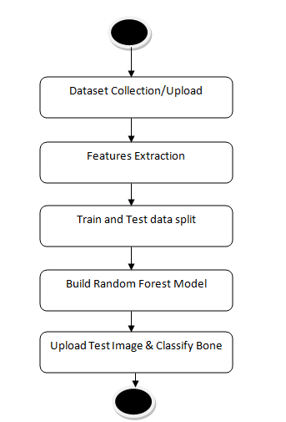
Fig.4.7:Activity Diagram

Data flow :
Data flow diagrams illustrate how data is processed by a system in terms of inputs and outputs. Data flow diagrams can be used to provide a clear representation of any business function. The technique starts with an overall picture of the business and continues by analyzing each of the functional areas of interest. This analysis can be carried out in precisely the level of detail required. The technique exploits a method called top-down expansion to conduct the analysis in a targeted way.
As the name suggests, Data Flow Diagram (DFD) is an illustration that explicates the passage of information in a process. A DFD can be easily drawn using simple symbols. Additionally, complicated processes can be easily automated by creating DFDs using easy-to-use, free downloadable diagramming tools. A DFD is a model for constructing and analyzing information processes. DFD illustrates the flow of information in a process depending upon the inputs and outputs. A DFD can also be referred to as a Process Model. A DFD demonstrates business or technical process with the support of the outside data saved, plus the data flowing from the process to another and the end results.

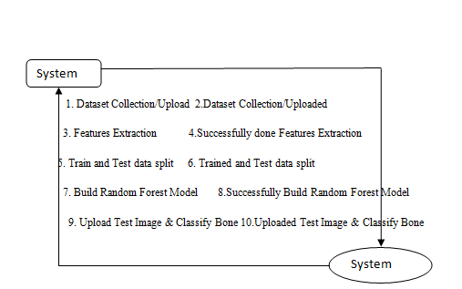
Fig.4.8:Data Flow
5. IMPLEMETATION
5.1 Python
Python is a general-purpose language. It has wide range of applications from Web development (like: Django and Bottle), scientific and mathematical computing (Orange, SymPy, NumPy) to desktop graphical user Interfaces (Pygame, Panda3D). The syntax of the language is clean and length of the code is relatively short. It's fun to work in Python because it allows you to think about the problem rather than focusing on the syntax.
History of Python:
Python is a fairly old language created by Guido Van Rossum. The design began in the late 1980s and was first released in February 1991.
Why Python was created?
In late 1980s, Guido Van Rossum was working on the Amoeba distributed operating system group. He wanted to use an interpreted language like ABC (ABC has simple easy-to-understand syntax) that could access the Amoeba system calls. So, he decided to create a language that was extensible. This led to design of a new language which was later named Python.
Why the name Python?
No. It wasn't named after a dangerous snake. Rossum was fan of a comedy series from late seventies. The name "Python" was adopted from the same series "Monty Python's Flying Circus".
Features of Python:
A simple language which is easier to learn
Python has a very simple and elegant syntax. It's much easier to read and write Python programs compared to other languages like: C++, Java, C#. Python makes programming fun and allows you to focus on the solution rather than syntax.
If you are a newbie, it's a great choice to start your journey with Python.
Free and open-source
You can freely use and distribute Python, even for commercial use. Not only can you use and distribute software’s written in it, you can even make changes to the Python's source code.
Python has a large community constantly improving it in each iteration.
Portability
You can move Python programs from one platform to another, and run it without any changes.
It runs seamlessly on almost all platforms including Windows, Mac OS X and Linux.
Extensible and Embeddable
Suppose an application requires high performance. You can easily combine pieces of C/C++ or other languages with Python code.
This will give your application high performance as well as scripting capabilities which other languages may not provide out of the box.
A high-level, interpreted language
Unlike C/C++, you don't have to worry about daunting tasks like memory management, garbage collection and so on.
Likewise, when you run Python code, it automatically converts your code to the language your computer understands. You don't need to worry about any lower-level operations.
Large standard libraries to solve common tasks
Python has a number of standard libraries which makes life of a programmer much easier since you don't have to write all the code yourself. For example: Need to connect MySQL database on a Web server? You can use MySQLdb library using import MySQLdb .
Standard libraries in Python are well tested and used by hundreds of people. So you can be sure that it won't break your application.
Object-oriented
Everything in Python is an object. Object oriented programming (OOP) helps you solve a complex problem intuitively.
With OOP, you are able to divide these complex problems into smaller sets by creating objects.
Applications of Python:
1. Simple Elegant Syntax
Programming in Python is fun. It's easier to understand and write Python code. Why? The syntax feels natural. Take this source code for an example:
a = 2
b = 3
sum = a + b
print(sum)
2. Not overly strict
You don't need to define the type of a variable in Python. Also, it's not necessary to add semicolon at the end of the statement.
Python enforces you to follow good practices (like proper indentation). These small things can make learning much easier for beginners.
3. Expressiveness of the language
Python allows you to write programs having greater functionality with fewer lines of code. Here's a link to the source code of Tic-tac-toe game with a graphical interface and a smart computer opponent in less than 500 lines of code. This is just an example. You will be amazed how much you can do with Python once you learn the basics.
4. Great Community and Support
Python has a large supporting community. There are numerous active forums online which can be handy if you are stuck.

5.2 Sample Code:
from tkinter import messagebox
from tkinter import *
from tkinter.filedialog import askopenfilename
from tkinter import simpledialog
import tkinter
from tkinter import filedialog
import matplotlib.pyplot as plt
import numpy as np
import pickle
import os
import cv2
from sklearn.model_selection import train_test_split
from sklearn.metrics import accuracy_score
from sklearn.metrics import classification_report
from sklearn.ensemble import RandomForestClassifier

main = tkinter.Tk()
main.title("CLASSIFICATION OF FRACTURED BONES USING MACHINE LEARNING")
main.geometry("1300x1200")

global filename
global X, Y
global X_train, X_test, y_train, y_test
labels = ['Chest', 'Elbow', 'Finger', 'Hand', 'Head', 'Shoulder', 'Wrist']
global classifier

def uploadDataset():
global filename
filename = filedialog.askdirectory(initialdir = ".")
pathlabel.config(text=filename)
text.delete('1.0', END)
text.insert(END,filename+' dataset loaded\n')

def featuresExtraction():
text.delete('1.0', END)
global X, Y
X = np.load('model/X.txt.npy')
Y = np.load('model/Y.txt.npy')
text.insert(END,"Available Bones images in dataset is : "+str(labels)+"\n")
text.insert(END,"Total images found in dataset : "+str(X.shape[0])+"\n")
text.insert(END,"Total available features in each image : "+str(X.shape[1])+"\n")
test = X[3]
test = test.reshape(32,32,3)
test = cv2.resize(test,(250,250))
cv2.imshow("Sample Image from dataset after features extraction",test)
cv2.waitKey(0)

def trainTestGenerator():
text.delete('1.0', END)
global X, Y
global X_train, X_test, y_train, y_test
X_train, X_test, y_train, y_test = train_test_split(X, Y, test_size=0.2, random_state=0)
text.insert(END,"Total images found in dataset : "+str(X.shape[0])+"\n")
text.insert(END,"Total images used to train Random Forest : "+str(X_train.shape[0])+"\n")
text.insert(END,"Total images used to test Random Forest : "+str(X_test.shape[0])+"\n")

def randomForest():
text.delete('1.0', END)
global X, Y
global X_train, X_test, y_train, y_test
global classifier
if os.path.exists('model/model.txt'):
with open('model/model.txt', 'rb') as file:
classifier = pickle.load(file)
file.close()
else:
classifier = RandomForestClassifier(n_estimators=200, random_state=0)
classifier.fit(X_train, y_train)
with open('model/model.txt', 'wb') as file:
pickle.dump(classifier, file)
file.close()
predict = classifier.predict(X_test)
random_acc = accuracy_score(y_test,predict)*100
text.insert(END,"Random Forest Bone Classification Accuracy on Test Images : "+str(random_acc)+"\n\n")
text.insert(END,"Random Forest Bone Classification Report on Test Images\n\n")
text.insert(END,str(classification_report(y_test, predict))+"\n")

def predict():
global classifier
filename = filedialog.askopenfilename(initialdir="testImages")
img = cv2.imread(filename)
img = cv2.resize(img, (32,32))
im2arr = np.array(img)
im2arr = im2arr.reshape(32,32,3)
test = np.asarray(im2arr)
test = test.astype('float32')
test = test/255
test = test.ravel()
imgData = []
imgData.append(test)
test = np.asarray(imgData)
print(test.shape)
predict = classifier.predict(test)[0]
print(predict)

img = cv2.imread(filename)
img = cv2.resize(img, (400,400))
cv2.putText(img, 'Bone Classified as : '+labels[predict], (10, 25), cv2.FONT_HERSHEY_SIMPLEX,0.7, (0, 255, 255), 2)
cv2.imshow('Bone Classified as : '+labels[predict], img)
cv2.waitKey(0)

font = ('times', 16, 'bold')
title = Label(main, text='CLASSIFICATION OF FRACTURED BONES USING MACHINE LEARNING')
title.config(bg='dark goldenrod', fg='white')
title.config(font=font)
title.config(height=3, width=120)
title.place(x=0,y=5)

font1 = ('times', 13, 'bold')
upload = Button(main, text="Dataset Collection or Upload", command=uploadDataset)
upload.place(x=700,y=100)
upload.config(font=font1)

pathlabel = Label(main)
pathlabel.config(bg='lawn green', fg='white')
pathlabel.config(font=font1)
pathlabel.place(x=700,y=150)

featuresButton = Button(main, text="Features Extraction", command=featuresExtraction)
featuresButton.place(x=700,y=200)
featuresButton.config(font=font1)

traintestButton = Button(main, text="Train & Test Data Generator", command=trainTestGenerator)
traintestButton.place(x=700,y=250)
traintestButton.config(font=font1)

rfButton = Button(main, text="Build Random Forest Model", command=randomForest)
rfButton.place(x=700,y=300)
rfButton.config(font=font1)

predictButton = Button(main, text="Upload Test Image & Classify Bone", command=predict)
predictButton.place(x=700,y=350)
predictButton.config(font=font1)

font1 = ('times', 12, 'bold')
text=Text(main,height=30,width=80)
scroll=Scrollbar(text)
text.configure(yscrollcommand=scroll.set)
text.place(x=10,y=100)
text.config(font=font1)

main.config(bg='RoyalBlue2')
main.mainloop()

6. TESTING:
Implementation and Testing:
Implementation is one of the most important tasks in project is the phase in which one has to be cautions because all the efforts undertaken during the project will be very interactive. Implementation is the most crucial stage in achieving successful system and giving the users confidence that the new system is workable and effective. Each program is tested individually at the time of development using the sample data and has verified that these programs link together in the way specified in the program specification. The computer system and its environment are tested to the satisfaction of the user.

Implementation

The implementation phase is less creative than system design. It is primarily concerned with user training, and file conversion. The system may be requiring extensive user training. The initial parameters of the system should be modifies as a result of a programming. A simple operating procedure is provided so that the user can understand the different functions clearly and quickly. The different reports can be obtained either on the inkjet or dot matrix printer, which is available at the disposal of the user. The proposed system is very easy to implement. In general implementation is used to mean the process of converting a new or revised system design into an operational one.

Testing
Testing is the process where the test data is prepared and is used for testing the modules individually and later the validation given for the fields. Then the system testing takes place which makes sure that all components of the system property functions as a unit. The test data should be chosen such that it passed through all possible condition. Actually testing is the state of implementation which aimed at ensuring that the system works accurately and efficiently before the actual operation commence. The following is the description of the testing strategies, which were carried out during the testing period.

System Testing
Testing has become an integral part of any system or project especially in the field of information technology. The importance of testing is a method of justifying, if one is ready to move further, be it to be check if one is capable to with stand the rigors of a particular situation cannot be underplayed and that is why testing before development is so critical. When the software is developed before it is given to user to use the software must be tested whether it is solving the purpose for which it is developed. This testing involves various types through which one can ensure the software is reliable. The program was tested logically and pattern of execution of the program for a set of data are repeated. Thus the code was exhaustively checked for all possible correct data and the outcomes were also checked.
Module Testing
To locate errors, each module is tested individually. This enables us to detect error and correct it without affecting any other modules. Whenever the program is not satisfying the required function, it must be corrected to get the required result. Thus all the modules are individually tested from bottom up starting with the smallest and lowest modules and proceeding to the next level. Each module in the system is tested separately. For example the job classification module is tested separately. This module is tested with different job and its approximate execution time and the result of the test is compared with the results that are prepared manually. The comparison shows that the results proposed system works efficiently than the existing system. Each module in the system is tested separately. In this system the resource classification and job scheduling modules are tested separately and their corresponding results are obtained which reduces the process waiting time.
Integration Testing
After the module testing, the integration testing is applied. When linking the modules there may be chance for errors to occur, these errors are corrected by using this testing. In this system all modules are connected and tested. The testing results are very correct. Thus the mapping of jobs with resources is done correctly by the system.

Acceptance Testing
When that user fined no major problems with its accuracy, the system passers through a final acceptance test. This test confirms that the system needs the original goals, objectives and requirements established during analysis without actual execution which elimination wastage of time and money acceptance tests on the shoulders of users and management, it is finally acceptable and ready for the operation.
Test Case Id | Test Case Name | Test Case Desc. | Test Steps |  |  |  | Test Case Status | Test Priority
 |  |  | Step | Expected |  | Actual
01 | Dataset Collection/Upload | Verify  Uploaded or not | If User may not upload | we cannot do any further operations | we can do further operations |  | High | High
02 | Features Extraction | Verify Data Features Extraction or not | If Features Extraction may not be Done | we cannot do any further operations | we can do further operations |  | High | High
03 | Train and Test data split | Verify Train and Test data split or not | If Train and Test data split may not be done | we cannot do any further operations | we can do further operations |  | High | High
04 | Build Random Forest Model | Verify Run Random Forest Model or not | If Random Forest Model may not Run | We cannot run  operation | We can Run the Operation |  | High | High
05 | Upload Test Image & Classify Bone | Verify Upload Test Image & Classify Bone or not | If Upload Test Image & Classify Bone May not be Recorded | we cannot do any further operations | we can do further operations |  | High | High
Table 6.1:Acceptance Table
7. SCREENSHOTS:
In this paper author is using Machine Learning Algorithm called Random Forest to predict/classify bone type and to train Random Forest algorithm author has used various types of bones images but author has not publish used dataset so I am using MURA bones dataset to train Random Forest Algorithm and then when we upload test image then Random Forest will classify type of uploaded bone image this classification will help in identifying fractures in bones whether fracture is in finger or hand or wrist etc.
To implement above modules we used below dataset
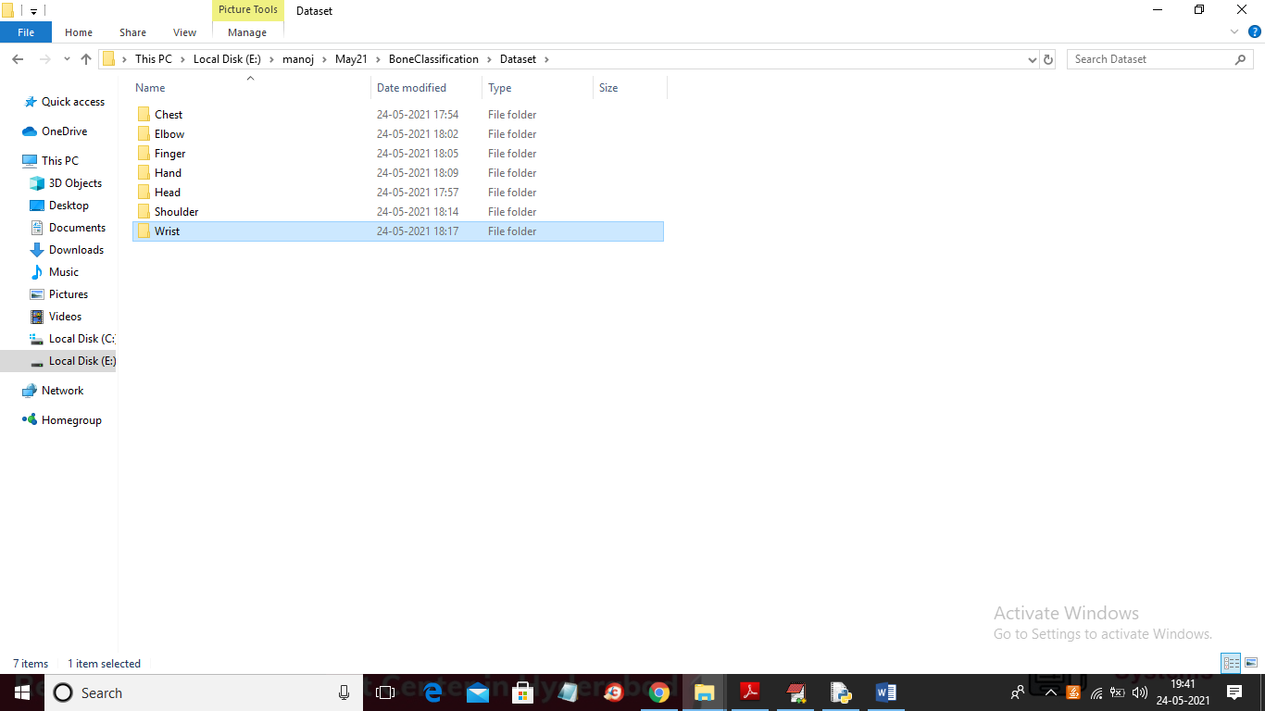
In above screen dataset contains 7 different types of images and each folder contains images of that bones and in below screen we can see images from chest folder
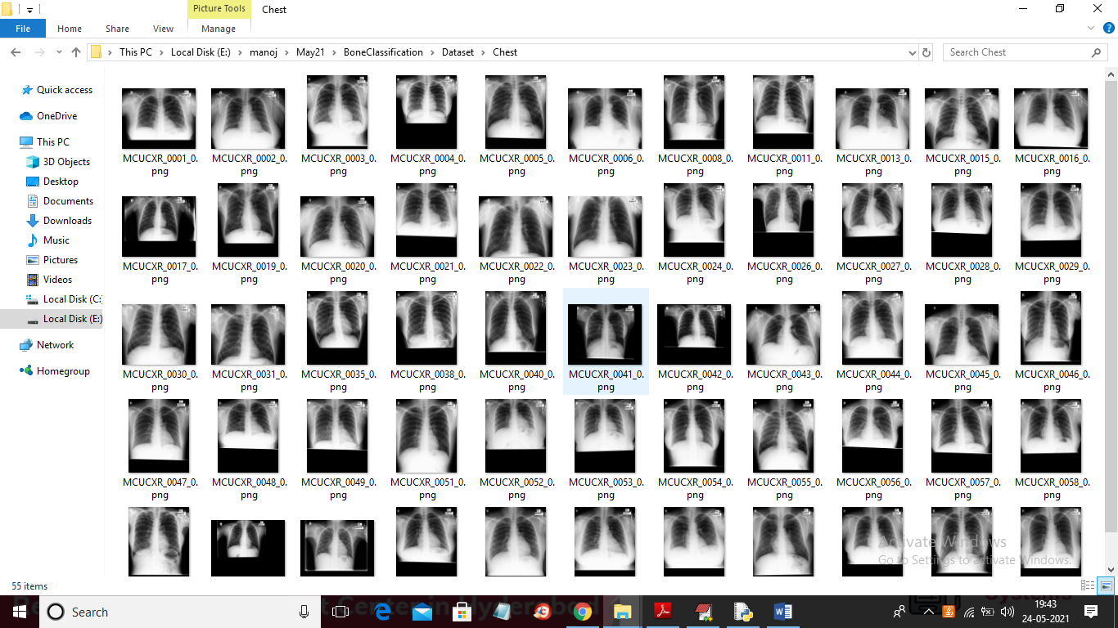
Similarly you can see different images in different folders
SCREEN SHOTS
To run project double click on ‘run.bat’ files to get below screen
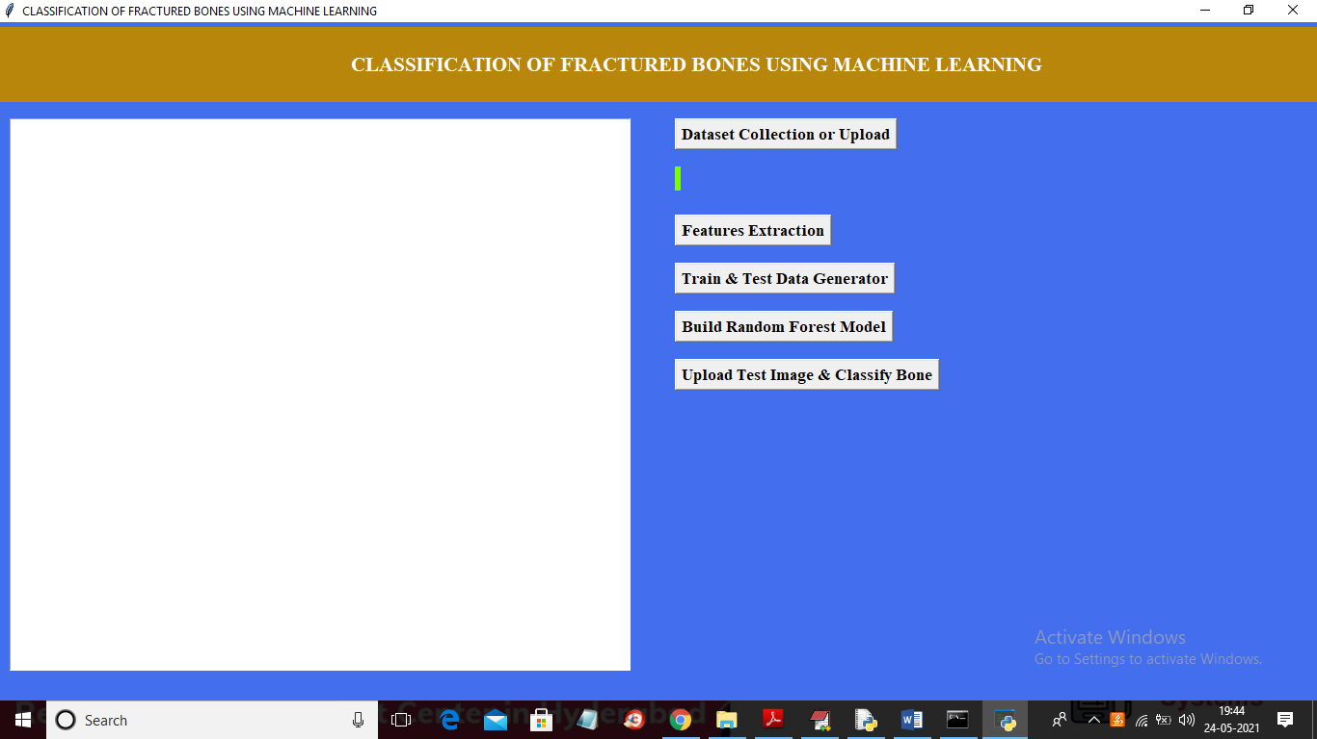
In above screen click on ‘Dataset Collection or Upload’ button to upload dataset and to get below screen
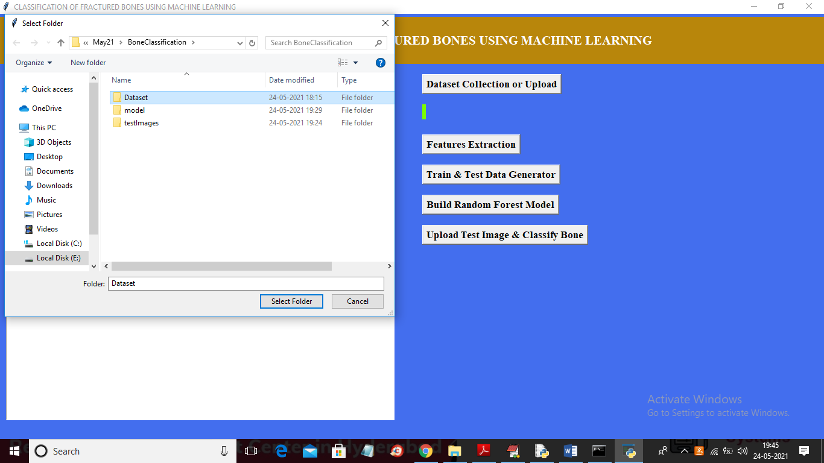
In above screen selecting and uploading ‘Dataset’ folder and then click on ‘Select Folder’ button to load dataset and to get below screen
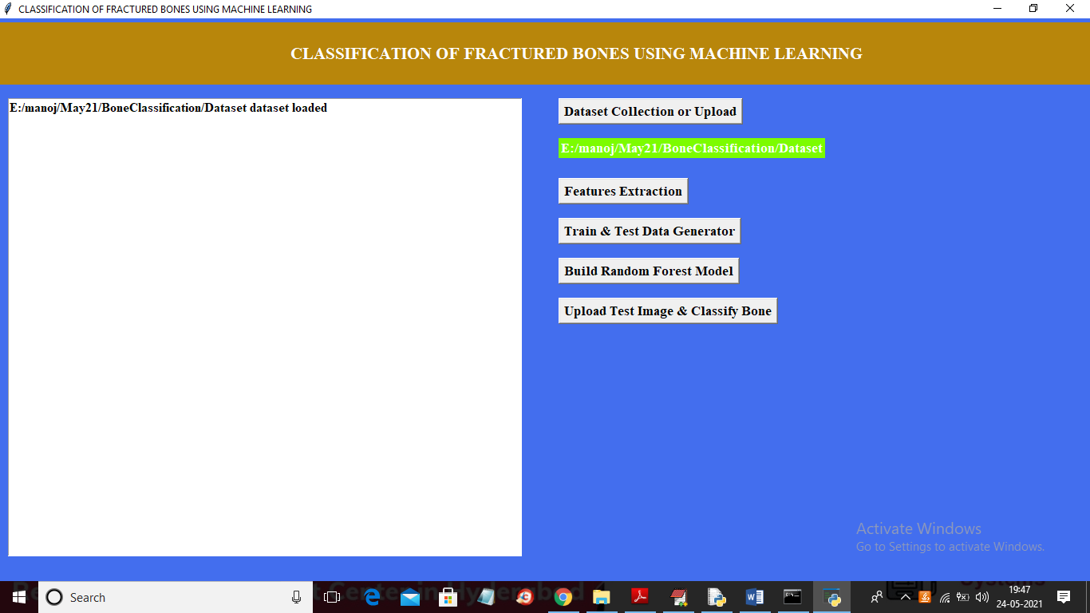
In above screen dataset loaded and now click on ‘Features Extraction’ button to extract features from dataset
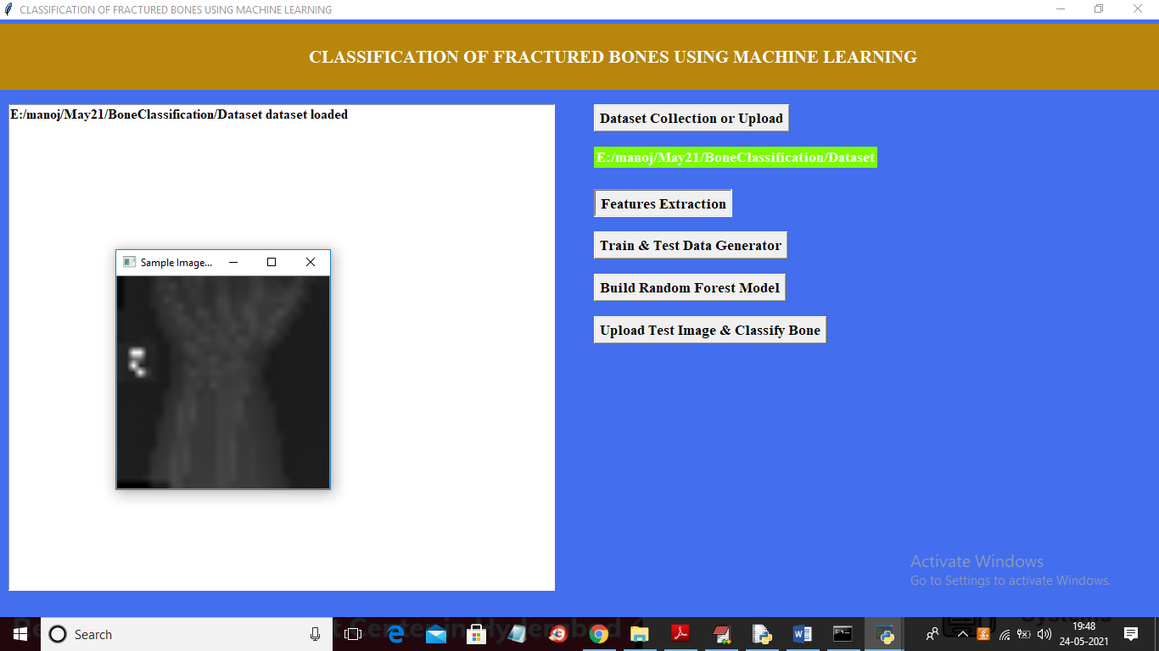
In above screen features extracted from each and then displaying one sample image to check whether dataset correctly loaded or not and now close above image to get below screen
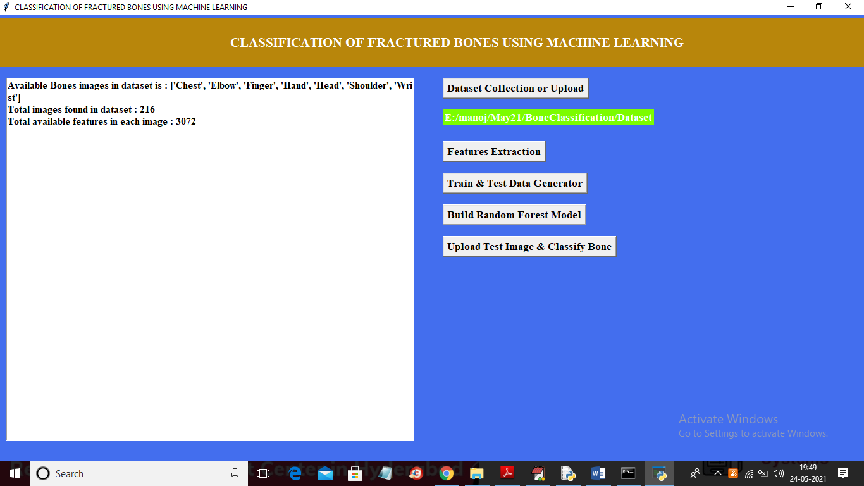
In above screen we can see in dataset 7 different types of bones are there and dataset contains 216 images and each image contains 3072 features or pixel values and now click on ‘Train & Test Data Generator’ button to split dataset into train and test part
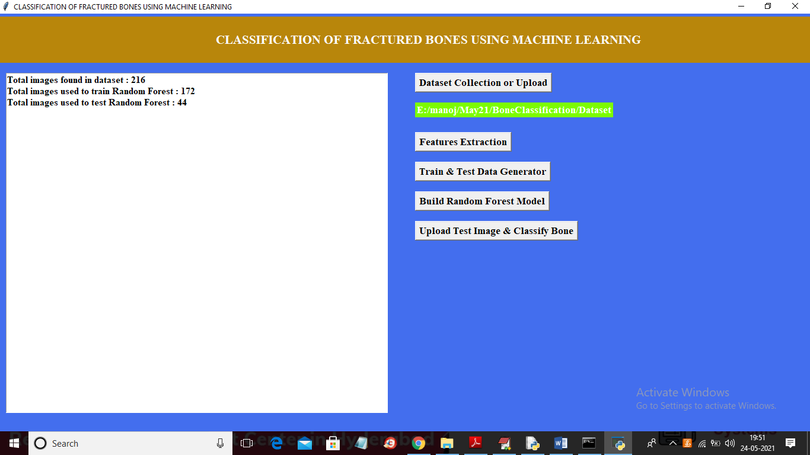
In above screen we can see dataset contains 216 images and then application using 172 images for training and 44 images for testing. Now train and test data is ready and now click on ‘Build Random Forest Model’ button to train Random Forest on above images.
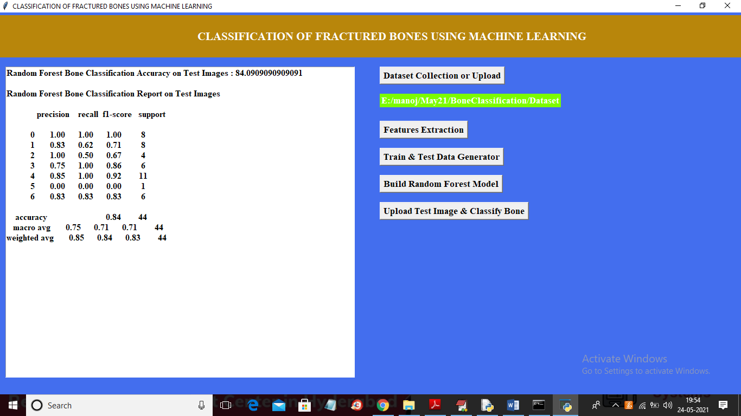
In above screen with random forest we got 84% accuracy and then calculate precision, recall, F1-SCORE for each image type. In above 0 refers to CHEST image and other number refers to other images. For example
labels = ['Chest', 'Elbow', 'Finger', 'Hand', 'Head', 'Shoulder', 'Wrist']
0 1 2 3 4 5 6
In above 2 lines we can see names of each image mapping to ID from 0 to 6. Now Random Forest model is generated and now click on ‘Upload Test Image & Classify Bone’ button to upload test image and then random forest will classify type of bone
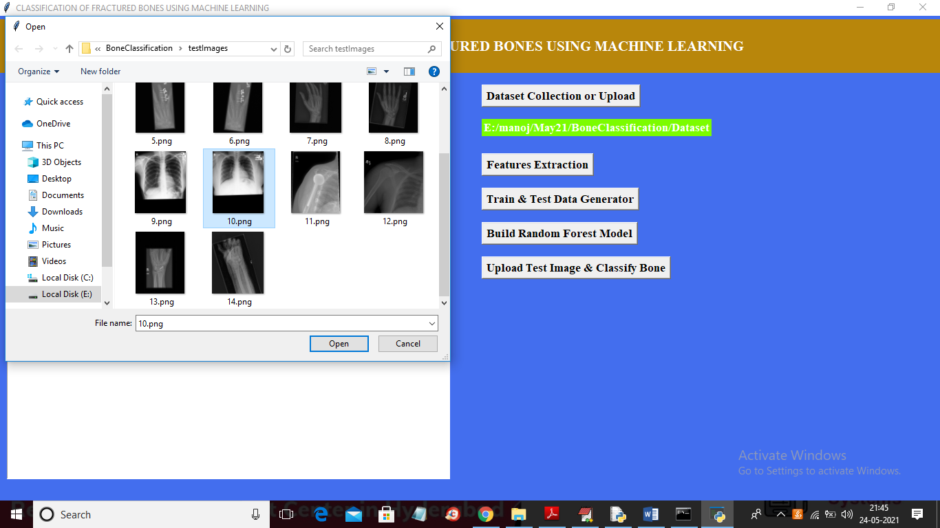
In above screen selecting and uploading ’10.png’ image and then click on ‘Open’ button to get below result
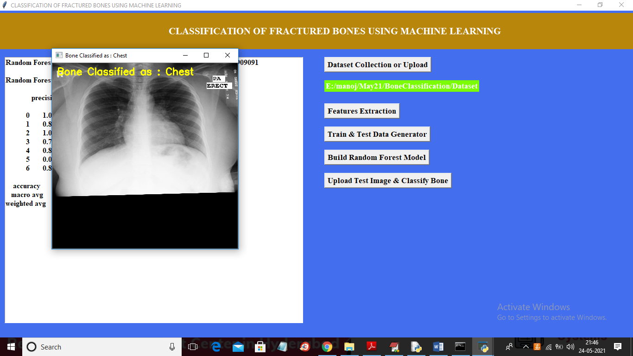
In above screen image bone is classified as ‘Chest’ and similarly you can upload and test remaining images
8. CONCLUSION:
In this paper author is using Machine Learning Algorithm called Random Forest to predict/classify bone type and to train Random Forest algorithm author has used various types of bones images but author has not publish used dataset so I am using MURA bones dataset to train Random Forest Algorithm and then when we upload test image then Random Forest will classify type of uploaded bone image this classification will help in identifying fractures in bones whether fracture is in finger or hand or wrist
9. REFERENCES:
[1] Edward V, Cephas Paul. and Hepzibah S, Hilda. (2015) , —A Robust Approach For Detection of the type of Fracture from XRay Images||, International Journal of Advanced Research in Computer and Communication Engineering, Vol. 4, Issue No. 3, pp.479-482.
[2] Deshmukh, Snehal., Zalte, Shivani., Vaidya, Shantanu. and Tangade, Parag. (2015), —Bone Fracture Detection Using Image Processing in Matlab||, International Journal of Advent Research in Computer and Electronics.
[3] Rathode, Hs. and Ali, Wahid. (2015), —MRI Brain Image Quantification Using artificial neural networks – A Review Report||, ISOI Journal of Engineering and Computer science, Vol. 1, Issue No. 1, pp. 48-55.
[4] O. Bandyopadhyay, A. Biswas, and B. B. Bhattacharya, “Classification of long-bone fractures based on digitalgeometric analysis of X-ray images,” Pattern Recognit. Image Anal., vol. 26, no. 4, pp. 742–757, 2016.
[5] U. Andayani et al., “Identification tibia and fibula bone fracture location using scanline algorithm,” J. Phys. Conf. Ser., vol. 978, p. 012043, 2018.
[6] N. D. Deokar and D. A. G. Thakur, “Design , Development and Analysis of Femur Bone by using Rapid Prototyping,” Int. J. Eng. Dev. Res., vol. 4, no. 3, pp. 881– 886, 2016.
[7] M. Khan, S. P. S. M. A. Sirdeshmukh, and K. Javed, “Evaluation of bone fracture in animal model using bioelectrical impedance analysis,” Perspect. Sci., vol. 8, pp. 567–569, 2016.
[8] G. Narayana, “Automatic Detection of Radius of Bone Fracture,” Int. Res. J. Eng. Technol., vol. 4, no. 6, pp. 4–7, 2017.
[9] I. Khatik, “A Study of Various Bone Fracture Detection Techniques,” Int. J. Eng. Comput. Sci., vol. 6, no. 5, pp. 6– 11, 2017.
[10] H. Kaur and A. Jain, “Detection of Fractures in Orthopedic X-Ray Images,” vol. 8, no. 3, pp. 545– 551, 2017.
[11] Zeelan Basha, C. M. A. K., Maruthi Padmaja, T., Balaji, G. N, “EAI Endorsed Transactions on Pervasive Health and Technology”, Vol. 5 ,Issue 18, 1-6,2019.
[12] P.Ganesan, S.Sivakumar, and S.Sundar, A Comparative Study on MMDBM Classifier Incorporating Various Sorting Procedure, “Indian Journal of Science and Technology” Vol 8(9), 868–874, May 2015.

